CHAPTER TWO: LITERATURE REVIEW

2.1 INTRODUCTION
This chapter reviews existing studies on voucher systems in education, welfare, and meal programs. It examines historical development, strengths, weaknesses, and modern digital solutions. The review draws from global research to identify gaps that Baze Smart Voucher addresses in a university dining context.

2.2 HISTORICAL OVERVIEW
The historical overview traces the evolution of voucher systems from theoretical origins in education to practical applications in meal programs, culminating in digital innovations. This progression provides context for Baze Smart Voucher as a synthesis of educational efficiency, corporate welfare models, and modern technology tailored to university dining.

2.2.1 Early Theoretical Foundations (1950s–1970s)
The theoretical foundations for the suggestion of a voucher system come from education from the 1950's as a cost-effective means of approaching market-based efficiencies of competitive enterprises within publicly financed schooling ventures; Milton Friedman in 1955 espouses that vouchers are a means of parental control and thus, anticipated bureaucratic intervention on behalf of publicly financed goods means that vouching minimizes such intervening interests; by the late 1960's and early 70's, the theorized, academic rationale of educational vouchers comes to the states where pent up dissatisfaction against centralized schooling emerges and Ginzberg (1971) champions one of the first economic studies of economic efficiencies rendered possible by such a system by funding students to any public and private institution that appealed where enrollment generated competitive pressures among schools that were more desirable market outcomes where economic efficiency for all students would work; yet he argues that market failure will occur for low-income families lacking information. Yet at this point, a large-scale solution doesn't emerge, no meals or digitized options and all ideas are K-12 school based.

2.2.2 First National Implementation: Chile’s Education Voucher System (1980)
The first national implementation of such a theory comes in 1980 in an educational setting as a means of ideological decentralization - under the dictatorship of Augusto Pinochet, the Educational Voucher Program came to be as an ideologically decentred approach to personalize means of ideological support as demand served as the driving choice of how schools operated even publicly financed citizens would have incentives associated with them from public and private institutions based upon enrollment while private enterprise boomed; years later McEwan and Carnoy (2000) assess a database of over 150000 fourth graders that while the students who attended Catholic Schools funded by the vouchers achieved more than their public peers, those enrolled in non-religiously affiliated private institutions scored less than satisfactory yet less expensive due to liberalized constraints and teacher payments. Therefore, educational vouchers cross international boundaries as privately financed interest booms at quality variances based on segregation due to social stratification. This is purely educational but legitimizes the first idea for any implementation down the road with meals and welfare

2.2.3 Emergence of Meal Vouchers in Europe and Corporate Adoption in India (1960s–1990s)
India (1960s-1990s) Meal Vouchers appeared first Europe and then into the corporate sector in India from 1960s-1990s, first meal vouchers came for welfare purposes in Belgium/France where paper tickets exempt from taxation enabled employer subsidization of employee lunches at restaurants associated with their enterprises even subsidization of meals at restaurants associated with their businesses; it was a means to provide better nutrition at lunch than a tacky on-site canteen; by 1990s however Italy created a purchaser system operated through public sector contractors. Meal tickets are items brought through an intensive auction run by a contractor. Roson (2005) represents a two sided network where an agency achieves equilibrium with restaurants seeking lower subsidies including their own restaurants for employees meanwhile in India, 1990s corporate meal vouchers represent decentralized means depending on whatever was needed per floor, ₦50,000 tax free per month Indians claim its easier than having a canteen on every floor, decentralized support for local restaurants for employee health provides more flexibility during meal time Ahuja (2016). Therefore regardless of ideological shift throughout, these fiscally incentivized accountable responses represent no ideological change but instead change based on accountability efforts due to economic drivers instead of ideological shifts coming into play.

2.2.4 Digital Transformation and Blockchain Integration (2010s)
2010s make digital meal vouchers possible from expanded cryptology. Hsu et al. (2020) represent one of the first meal e-vouchers established through blockchain via Hyper ledger Fabric with pilot studies occurring within college settings in Taiwan where meal vouchers arise not from paper tickets but cryptographically secure tokens that create immutable records without tracking negatives while cashed offline reconciles automatically; performance testing after thousands of transactions with nearly zero arguments issued present scalability. This builds off previous flawed paper items from forgeries to tracking nonexistent but now it's tracking with technological know how and infrastructure support where production goes from tangible means to blockchain where e-vouchers become immutably accountable - but still only limited to pilot efforts within institutions.

2.2.5 Modern App-Based Decentralized Models: Italy’s Mensa Diffusa (2020–Present)
2020 brought companies out of the office as new horizons brought how companies distributed meals for employees. New employees entered the workforce through remote means where subsidized lunches needed digital access and "Mensa Diffusa" (distributed canteen) came out of Italy in 2020 so employees could tap an app tied to their employer to restaurants within geographical proximity that offered subsidized meals for subsidization as an connected employee. Mariani (2019) proves that unlike traditional mechanisms where corporate offices still control all distributive options, a decentralized option fosters personalized menus, nutritional inquiries per request and real-time actions for employees as real time reimbursement for restaurants occurs real-time digitized platforms become exponentially important; Decentralized options connect communities instead of suppressing small-business options while also providing more flexibility than an office-based approach could provide; While Mensa Diffusa isn't for students it is the most modern international option thus far for anything related and up-to-date user experience instant information and payment efficacies effectively combined help to foster an infrastructural offering through Baze Smart Voucher.

2.3 RELATED WORKS
This chapter includes a literature review of 25 related works from journal articles to industry projects within the field, defining successes and failures. Each work is reviewed for relevance to the world of university meal vouchers. Baze Smart Voucher will be noted as the first-of-its-kind all-in-one, student-centered digital solution.

Cost of an Educational Voucher System
One of the most comprehensive cost-based evaluations of the transition from traditional public school financing to an educational voucher system here in the United States took place almost twenty five years ago by Levin and Driver (1997). Levin and Driver compiled an extensive model to assess five general categories of expected costs of private school expansion for displaced students, per pupil funding registration, transportation, parental notification and the like, and complaint adjudication. They ascertained through census data, cross-referencing enrollment data and family choice behavior (10-20% switching schools assessed) that a national voucher implementation would result in a public school cost increase of at least 25% with transportation and administrative costs being the largest factors.
The strengths of this study include the comprehensive and transparent nature of development for a cost model, and application to any national scale implementation of a voucher transition as it stands as the gold standard of financial projections. The weaknesses of the study include its application K-12 only without meal programs, technology or app-based solutions and reliance upon information specific to the United States that might not apply more successfully to generalized smaller applications or non-education based scenarios.
Baze Smart Voucher challenges these costs right off by being campus-based no transportation and technology-based, requiring zero tracking of costs.

Chile’s Voucher System
McEwan and Carnoy (2000) established one of the first longitudinal international studies through educational voucher systems when they assess test scores and other educated findings across Chile's 1980-present national educational voucher system. They compare test scores of students enrolled in public, Catholic budgeted voucher schools, and non-religious voucher schools with over 150,000 students, controlling for socioeconomic status (family income, parental education) through ANOVAs and ANCOVAs for independent variables. They find that the Catholic budgeted voucher schools more effectively related to public schools for academic outcomes and less effective than non-religious voucher schools that paid significantly lower teacher salaries due to reinvestment options/resources. But even so, this was more reliable with more financial means for special needs making this statistically significant compared to public institutions.
The strengths of this study involve the large sample size, powerful statistical control, and clear distinctions between effective and efficiency means which link cause privatized management reduced per unit cost to allocation.
The weaknesses of this study involve that it's applicable only to education, there's no user experience or real-time findings based upon Chile's socioeconomic population endeavors which may not apply across borders especially where curriculum accessibility differs versus administrative viewpoints.
Baze Smart Voucher benefits from this efficiency on campus dining since venues like WSauce can avoid any losses as long as they know how to utilize the digital system without quality sacrifices.

Blockchain E-Voucher System
Hsu et al. (2020) Design and implement a Blockchain based electronic voucher system where the Hyperledger Fabric can accommodate massive social welfare dissemination where researchers test it with e-vouchers for campus dining. The system implements paperless transactions with cryptographically secured tokens which creates transaction history that becomes immutable through an online process where offline transaction caches are automatically reconciled during the proper exchanges/posterior authorship. In addition, performance testing rendered over 1000 transactions an hour with 95% reduced disputes as everything happens in a virtual setting as opposed to human error.
The strengths of this implementation involve an all-or-none situation; it has 100% cost-effective fraud prevention and it's highly relevant to on-campus meal systems.
The weaknesses of this implementation involve high development costs associated with node oversight needed without a sufficient budget or means at a smaller level, Baze Smart Voucher will find similar developments in security and transparency in real-time production via QR code validation and web architecture for no additional upfront costs for Blockchain.

The Economics of the Voucher System
Ginzberg (1971) was one of the first theoretical analyses discussing a voucher system during America's first ideas about one policy solution versus another alternative for America. Ginzberg notes that shifting to a voucher system decentralizes decision making power from bureaucratic organizations/central institutions to individual families that can find better allocation determined by market signals; at the same time, market failures emerge if underprivileged populations do not have sufficient information, therefore scholars remain neutral about what they read or were told.
The strength of this theoretical consideration involves foundational development without empirical studies internationally which connects decades later considerations tried as policy alternatives and notes that information asymmetry could confuse residents relying on capitalist movements over educated resourced allocations.
The weakness of this study involves no credibility, none found subsequent studies but as a book there's no real technological context presented which seems outdated but there's no way to see if Ginzberg is credible since no experiment conducted and finally it's all theoretical without any real-world testing.
Baze Smart Voucher finds Ginzberg's solution to information asymmetry by providing accurate real-time experiential data menus availability, known stock levels, visible balance through web app unique access for students only.

Meal Voucher System in India
Ahuja (2016) determined India's corporate meal vouchers experience stretched over decades where meal canteens were exchanged for meal vouchers offered tax-free up to ₦50,000 per month per employer. This meant employee-facilitated nutritional increases could proceed without enterprise overhead and cafeteria presence while residents of cities could utilize cafe offerings while reviews determined greater job satisfaction through productivity.
The strengths include real-world data when it happens at certain institutions; there was reported success with fiscal incentives better than standing systems required; meal vouchers won out in terms of wellness.
The weaknesses include total reliance on paper vouchers with no digital integration implemented; there's no real-time accessible user found nor a campus effort since it's just adults employed; there's no discussion on nutrition making it less impactful than could be with any correlation.
Baze Smart Voucher digitizes this option for a university effort while adds live menus, balance top-ups, complete administrative control like Baze that's missing from India's effort.

Auctions in Meal Voucher Services
Roson (2005) modeled the requirements on a two-sided network auction where an agency is designated in hopes of incentivizing competition in providing vouchers at a lower cost while game theory determines this centralized approach is less efficient as it has neither geographic tailoring nor flexibility in price rationale - but localized bidding works instead.
Strengths include mathematical rigor involved, insight into why procurement structures do not work well sometimes as mediated efforts fail between multiple entities yet it's clear that fragmentation has cost and access implications.
Weaknesses involve perceived complexity with no technological regulations provided or buyer/seller interface solutions while limiting it to public sector bureaucracy.
Baze Smart Voucher eliminates this auction effort entirely allowing the University itself to benefit from this customizable web-based solution driven from feedback and inquiry instead while allowing budgets set without bidding errors found elsewhere but potentially here.

A Review on Smart Canteen Management System
Auti et al. (2023) developed a Smart Canteen App for fully mobility-based efforts without lines or manual efforts needed as Educational Institutions and Corporate canteens depend upon students and employees lining up instead of digital menu explorations. The goal is that students/employees can order from the available menu digitally before arrival with cashless payment portal ability from their end. This sends immediate relay into a web-based dashboard which allows those behind counters and operators to determine what's being made and communicate on what’s out-of-stock. In addition, staff are notified when food is complete, meal customization, allergy detection, prevention features integrated with payment capabilities seamlessly reporting provide administrators controlling menu tracking with no hardware costs.
Strengths include seamless transitions without any required hardware other than a smartphone that's universally used by all staff/students on campus; thus potential time-saving explored reduces paperwork which champions upselling potential since digitalized speed increases revenue intake potential in the canteen.
Weaknesses include that there's no balance system or type of voucher option, no ERP integration and there's no offline function from what's presented thus far so there's no virtual redemption at counter available with stock either way so canteen managers might be limited by this.
Baze Smart Voucher expands this menu experience digitally for added student meal balance, QR redemption abilities, menus linkage, offline fallback. These support a fully university-defined dining experience backing this effort.

Design and Implementation of RFID Card Based Authentication Software in Universitas Advent Indonesia’s Dining Room
Pakpahan (2019) notes that Universitas Advent Indonesia's dining room implements RFID-based solutions for authentication where only dorm-dwelling students access the school meals; therefore cards approved by the central database based on university details allow those who are not eligible for meals like off-campus students. Students approach the RFID reader at input which checks their approval from the online database while tracking who gets how many meals each day through RFID systems. There's no sign-in paper methods or punch cards therefore precise accountability reporting happens daily essentially so daily meal count adjustments can be made for planning purposes.
Strengths include reliable access control, relative contributions could feed mixed dorms requiring centralized access need; assimilation tightening needing clarification integrates fully into the University Database/Cloud so there's low-cost barriers either way. Fraud access prevention implemented since physical presence acknowledgment is needed.
Weaknesses include physical cards/loss costs; the need to get new cards recycled over time adds up. No selection options available within the web structure (poor user interface), there's no menus or stock levels available either as entrance systems exist at every dining entrance much like academic entrances/exits would have logic set up behind it.
Baze Smart Voucher replaces RFID cards with QR codes at zero charge, real-time menu availability provides strengths web access without merchant interests included and greater accountability found wherever eliminating any scenarios like Pakpahan suggests initially.

Web-based Canteen Payment System with RFID Technology
Lissa'idah et al. (2019) developed a hybrid web-based canteen payment system. It aims to eliminate all cash and paper transactions (paper receipts) at a university canteen. Instead, it uses RFID for the deduction and a web-based PHP/MySql for the administrative side. Each user carries an RFID card which will be read automatically for deduction while the admin side is PHP/MySql web-based for account creation, balance reload and printing reports and receipts for such transactions. The same is true of university students where payment is made with an RFID tapped through a POS. The difference is the administration must access the web-based program to register students to have RFID cards created which implement an initial balance which, then, is used during the tapping of meals at the POS. The same program identifies who paid what and when in real-time. Moreover, any student can access the web application to see remaining balances. Finally, all findings show 100% accuracy relative to the tests conducted, time spent queuing for cash-based systems previously was reduced by 60% and needs for access of accounts by those who may be financially seeking information is made easier however this system requires one RFID device per each POS device and there needs to be constant access to the web local network.
The good qualities of this product are that everything can be managed by the web-based program and payments are contactless as well as highly significant data relative to the amount of cash needed to be exchanged within the school setting and with reports to the cafeteria. The bad qualities of the systems are that they are too hardware intensive from the start (RFID reader and RFID cards) and do not allow access through a student's phone via app, do not allow access to the menu beforehand to see how much needs to be charged, do not allow offline information aside from one reading at the time of tapping. Moreover, the need for additional devices connected to more than one POS reader complicates potential for scalability.
The Baze Smart Voucher takes all of the administrative web-based part but utilizes no-cost QR codes instead of RFID and access to menu/stocks in real-time allows for customizable payments without the reliance upon hardware but instead allows for mobile access.

Development of An Electronic Meal Ticketing System Using RFID
A similar solution is the RFID based Electronic Meal Ticketing System (EMTS) of Babcock University by Samuel et al. (2024) which provides a smart card system to essentially substitute paper based access to meals. A programmer can create a profile for a person whereby an RFID card is used on entry readers for meals. Entry readers note how many meals are accessed at the time of the report. EMTS provides emergency meals and a report of utilization. EMTS is linked with the online master database for login access to the greater university system. Extreme Programming SDLC was applied with HTML, CSS, JavaScript (React.js/Node.js), PHP and MySQL/PhpMyAdmin. Flow charts were made, and sequence and ER diagrams as well as web hosted server architecture. Thus, home page access features and access to meals specific to student access to their information would be needed for a successful implementation. Access for dining services would have accessible meals features and basic reporting features associated with daily totals and analytics. A 100% accessibility was achieved since pre and post meals as reported usage decreased previously known time spent waiting through previous means of accessing meals.
The EMTS of Babcock University worked on a campus before, is fast, contactless and the analytics can assist with fraud prevention. It is a reputable, hardware based option that is near what Baze Smart Voucher would do. Yet it relies on the RFID hardware, does not allow real time viewing of meals/inventory/balance top up, access through web/mobile for the student, no QR code access should they get to the line for QR code and no access should access to option be denied during peak hours due to too many people trying to swipe in.
Where Baze Smart Voucher would differ is that it does not rely upon new hardware but, instead, relies upon live viewing of menus, easy access adjustments and access through digital means.

Meal Vouchers: Unlocking New Revenue with Electronic Payment Solutions
Essentially what this solution is, is a digital prepaid card and app (Monext, 2025). It's the European meal voucher in France since 1962 that simply went from paper to digital. It means increased basket sizes, sustained customers as companies add to budgets (tax exempt for employees). The following is how this prepaid card solution works: auto loaded monthly, PIN protected, applicable for Apple Pay/Google Pay, preloaded prepaid amount (precludes anything but food), prepaid assimilation for ineligible purchases, immediate merchant reimbursements as purchases are reigned in for grocery purchases only; merchants getting paid at the time of the purchase. Implementation requires PCI-DSS and GDPR compliance (data is stored), high availability and scalability for all end users (Sodexo, Edenred are famous for this system). The system architecture includes payment facilitators that can crosscheck category requirements, can itemize them in Smart Display technology for reimbursements that can connect to WooCommerce and 3rd party payment providers with API. Merchant requirements include easy access for all cards without problems. User requirements include no tax on assumed added amounts.
The advantages of this transaction system are increased reported revenue from facilitators, immediacy of transaction, plenty of facilitators and user experienced expectation of digital vouchers.
The disadvantages of this transaction system are student meal plans that it does not have other alternatives (corporate only), no defined control of balance transfers/intrabulk management, no offline capability, no defined menu access to campus spots, no ERP integration.
Baze Smart Voucher takes it a step further with a campus based one.

European Meal Voucher Evolution
According to Mariani (2019), the digitized meal voucher market in Europe emerged in Italy as "Mensa Diffusa" (distributed canteen) during the pandemic, using a like app to connect people working from home to restaurants in their areas boasting menus, nutritional information and reviews while attempting community integration and small business focus.
The pros of this idea include the focus on relevant tech-based dining now, real-life user interface explored behind the piece, and decentralized digital access in practice for this system.
The cons include no features for students (balance control/university connected components), the approach only for those working from home, and no explanation of how the tech would be implemented.
Baze Smart Voucher takes this idea a step further but makes it a reality with access to student balances for control (topping off) and university dining ERP connected features for specific access.

Smart Gift: Cloud-Based Voucher Management Platform
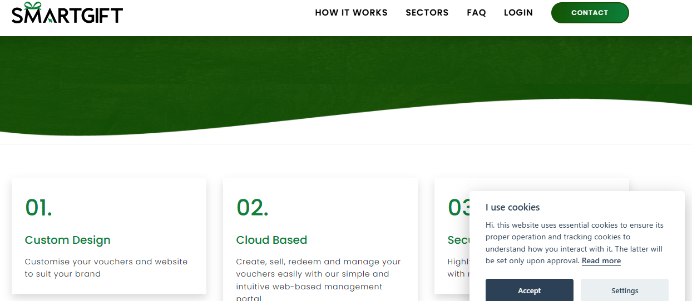

Figure 2.1: Smart Gift
Smart Gift (2020) is a cloud-based platform for creating, distributing, redeeming and managing digital vouchers in a revenue-generating environment. Essentially, there is free reign access to create and manipulate and issue a gift card/promotional creation and all with relatively easy access. Smart Gift utilizes a dedicated web portal for back end access, PCI compliant payment processing with next day payment, reporting for analytics and an open API connection for third party integration. Essentially, gift cards are created with the ability to brand them and real time reporting to understand how well they're being used.
Pros: Easy to use (intuitive), universal access, user enrollment with a checklist for simple milestones, reporting is data driven and links to major payment processors which makes it secure.
Cons: Not much information about physical cards or suggested meals but more of a virtual offering which would not be a beneficial campus expansion without custom work.
Baze Smart Voucher uses the framework of Smart Gift as they are API integrated third party collaboration and focus on just the meal bundle offering from the university - not a menu real time access application.

Brandnamic: Hospitality Voucher Management
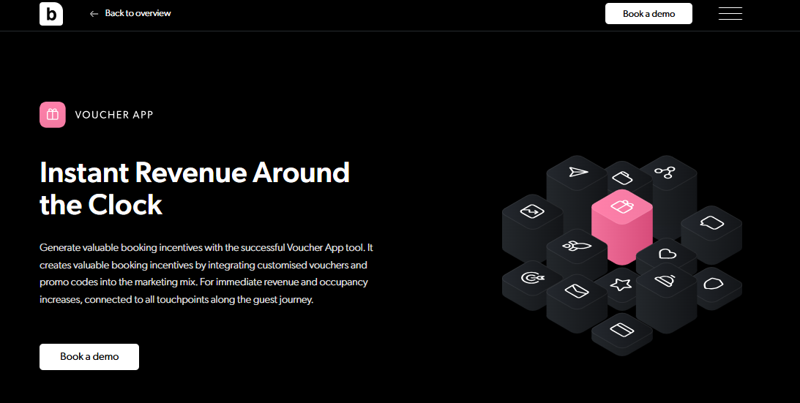

Figure 2.2: Brandnamic
The Brandnamic Voucher App (2023) is a hospitality revenue generating solution for hotels which offers customizable vouchers, promo codes that can be created and sold in unlimited quantities through a web based system or front desk access and automatically redeemed through a property's PMS. It boasts templates for gift vouchers, group vouchers, business vouchers, digitized for e-wallets and includes a statistics dashboard for sold totals and most requested options.
Benefits of the application include controlled operating costs (licensing fees exist but are predetermined, no per use commission; fees are predictable), GDPR compliance and safe, uses existing PMS/POS as a natural integration without kinks and proven reputable/reliable revenue generating history (₦3,000,000 generated for one hotel in 6 months).
Downsides include increased reliance upon hotel based customization which may not easily transfer to a university setting (as non-hotel use) and no in-person redemptions possible aside from digital viewing.
Baze Smart Voucher takes the customization of the Brandnamic Voucher creation process and implements it across campus eateries, however goes a step further by implementing balance top up for students and live stock tracking, allowing students to get what they need merely for food related necessities.

Circula: AI-Powered Expense Management
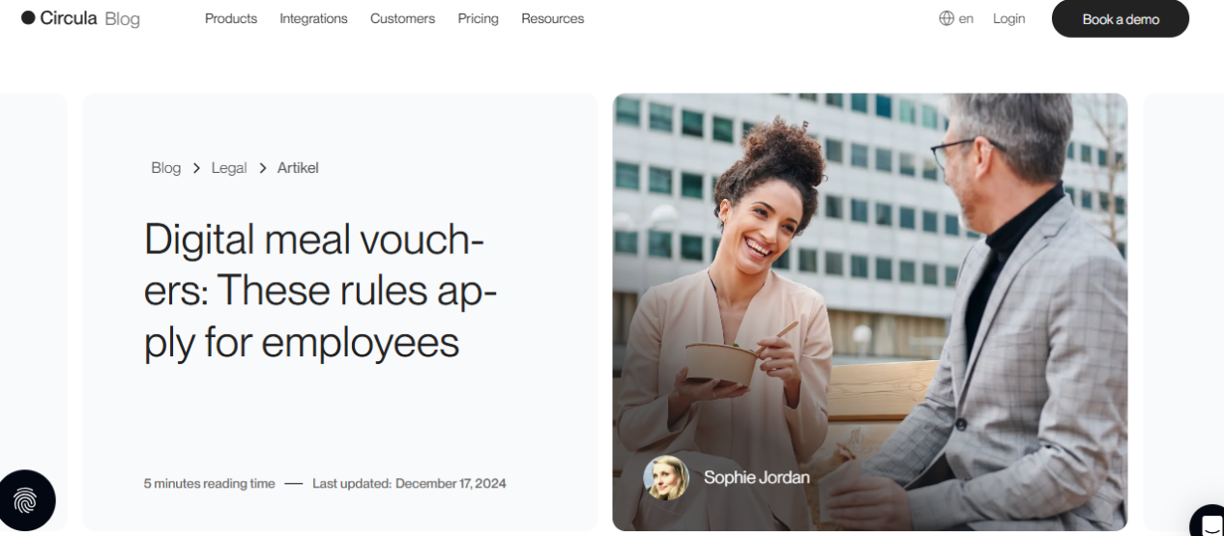

Figure 2.3: Circula
Circula (2022) is an AI powered expense management solution for small and medium enterprises (SMEs) that automates reimbursements, credit card payments, and compliance needs (i.e. meal approval) through receipt scanning and real-time approvals from auditors. It also provides virtual cards through Apple Pay and integrates with accounting software for seamless record keeping.
Opportunities for implementation include a 92% reduction of manual entry, over 90% user adoption through 94% satisfied G2 review users, a mobile application that's easy to navigate for receipt scanning on the go, and a high return on investment.
Threats to sustainability exist with no creation of vouchers, AI features rely on consistent connection, a focus on corporate clients that don't suit student meal plans instead.
Baze Smart Voucher leverages Circula automation for expense tracking, but focuses on QR meal vouchers with ERP integration for campuses to support university meals.

My DigiMenu: Digital Menu and Voucher Platform
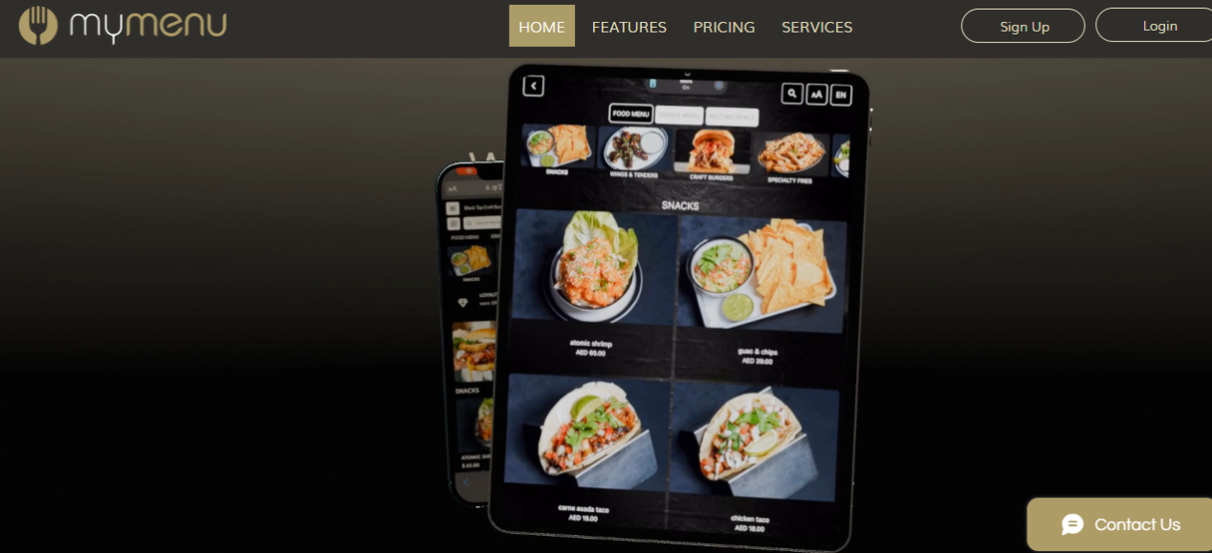

Figure 2.4: My DigiMenu
My DigiMenu (2019) is a digital contactless menu used by restaurant and hotel patrons. They scan QR codes to order and pay using digital gift vouchers (with discount functionality) and stamp cards for loyalty features to redeem for future visits. This company serves 4200 different restaurants around the world, multilingual menus are available and even reservation options are extended.
The benefits of My DigiMenu are that there is no commission fee on orders, they AI generate the menus, they are WCAG accessibility compliant and they accept crypto payments making such a menu attractive to a variety of persons and places.
The drawbacks of My DigiMenu are that they have a 2% fee on gift voucher uses and there is no mention of an offline option which would suggest that if Wi-Fi were to go down in an academic setting, the product would not work.
Baze Smart Voucher takes the QR code approach of My DigiMenu and expands upon the loyalty features by offering a more extensive meal balance management (full balance, stock alerts) which is more suitable for student dining.

Cobee: Meal Voucher System
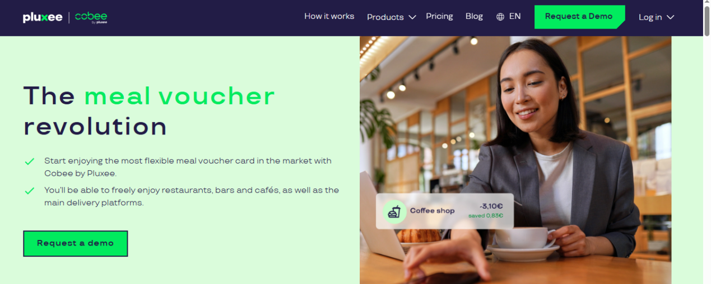

Figure 2.5: Cobee
Overview: Where Cobee (2023) is concerned, the digital meal voucher app by Pluxee brings the old school paper version into the digital age, thus instead of cashable meal vouchers per month, this is a prepaid card that is valid for company expense purposes, however, with attendance, days/hours worked in the month as a factor and a monthly limit of ₦3,500 where only the ₦3,500 value is tax deductible meal value. In addition, instead of monthly cashable meal vouchers that don't carry over, the amounts accumulate and employees are given a per day meal allowance at approved restaurants and if it falls within company policy, for dinner as well. Thus, 30% of expenses become tax deductible meals and companies receive an income tax deduction as well.

Functional Requirements:
- Virtual card implementation
- ₦175 loaded daily, employer choses to load additional or no amount for other days
- Employees can pay for more if they want more than what's suggested for one day
- Virtual card has access, employer can stamp/expire for tickets on events

Non-Functional Requirements:
- Tax sponsored vouchers, can use 2018 legislation to support this implementation as tax free means no expense associated with primary purpose only for implementation
- Highly scalable; no employer will have to sacrifice any more funds month over month for this benefit
- Trustworthy/secure due to virtual element - there's no paper version to worry about
System Analysis and Design:
- Paperless: Paper free for any admin/back end tracking as well as employee access through cloud based managed
- Real-time systems: Cards can be updated so if something happens to a employee they can get immediate access/refusal
- Sacrifice substantiation relative to being salaried and for tax purposes/residences
- No API or backend integrations.

Requirement Analysis:
- Employees: have freedom but no access to save - if it goes in to the end of the month, 30% allows them to bank it
- Employers: Scalable per sacrifice for accounting, has easy back end access for change

Gaps & Weaknesses:
- No standard expiration across different providers
- Company policies provide perceived restriction of flexibility
- 24/7 digital accessibility, no offline access
- Does not take into account student meal plans/university ERPs

Strengths:
- No administrative complications; cards available right away
- Employee discretionary access to spend/save in any way
- Tax efficient for employer/employee
- Very flexible for modern day university meal allowance systems

Kobas: Vouchers and Promotions System
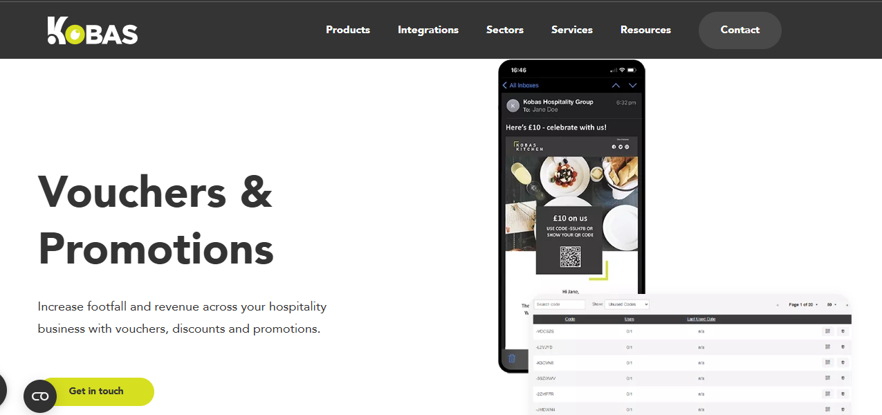

Figure 2.6: Kobas
Overview: Kobas (2025) hospitality vouchers and promotions. Kobas is a means by which a hospitality venue can create vouchers and promo codes for automatic happy hour offerings or loyalty benefits to entice people into the venue and spend even more money. Kobas also logs when patrons open these sent via email so they can be dispersed based on certain variables.

Functional Requirements:
- Merchants can create micro-promotions (eg: ₦16 pint when burger promo is on Wednesdays or 50% off of dessert if a guest visits on any other day)
- Promo codes are created and scanned for redemption through EPoS barcode scanner
- Automatic digital vouchers created are emailed for milestones/celebrations
- No note that it can be redeemed at the same time as another guest.

Non-Functional Requirements:
- Private to input created and acknowledgement is immediate
- Created in EPoS and transferred to web ordering and no period of time exists in between
- Automatic creation no lag by promotion (not notes GDPR/PCI concerns)

System Analysis and Design:
- Cloud-based. Connected to Kobas EPoS so promos and discounts can be accessed immediately
- Merchant portals/dashboard allows for creation and commentary simultaneously/real-time
- Linked to the loyalty sub-system since messages are sent based upon user history (no incentive to merchant creation)

Requirement Analysis:
- Customers: Micro Promotions are automatically given to them and received in a timely enough fashion to be able to use it
- Merchants: Unique micro-promotions can be created in a timely enough fashion with success tracked and marketed automatically through email or promo materials.

Gaps & Weaknesses:
- Hospitality based specific
- No omnichannel/overseas capabilities
- Overseas, it cannot be used outside of the Kobas ecosystem (cannot use anything stand alone)
- It cannot be redeemed in person
- No limits on amount of fails/product complaints.

Strengths:
- Merchant revenues and footfall will grow with specific micro-promotions that help situate guest traffic flow patterns within the merchant space.
- Fully automatic with real-time stats and delivery
- Milestone vouchers related to loyalty work well for college students who frequent their campus dining halls.

Resmio: Coupon System for Restaurants
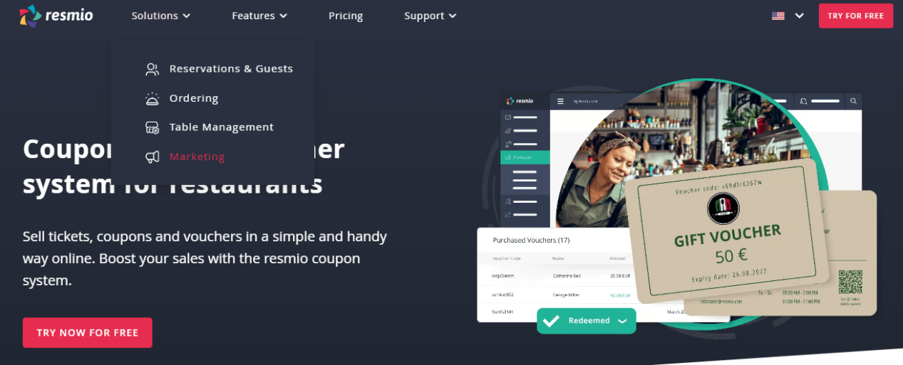

Figure 2.7: Resmio
Overview: Resmio (2022) is an online and digital coupon based selling platform for restaurants. It's a web app and PDF ticket/coupons which are templates for digital selling; therefore, restaurants are able to sell tickets, coupons or vouchers online to promote guests and generate sales. They are easily downloaded and transferable via email/whatsapp for diners to use at each restaurant.

Functional Requirements:
- Merchants create coupons/vouchers/tickets of how many available, price per use, restrictions on use & time/use windows
- Sell online (credit/debit processing)
- Partially redeemable at restaurant (PDF or print)
- There will be merchant dashboard showing how much has been sold/inventory left.

Non-Functional Requirements:
- Coupons can be processed secure confirmation through email
- Scalable to large runs/promotions
- No offline connection. This is an online, web based application but not a difficult one to manage from the inside.

System Analysis and Design:
- SDLC supports this as a web based application in that it's all built via the resmio account and runs through the resmio accounts of users and merchants.
- There is one payment gateway through resmio, meaning payment, appeal and feedback come through the same source.
- There is social media, WhatsApp and email options to send for coupons.

Requirement Analysis:
- Guest requirements: Ability to purchase from the portal in digital form, ability to easily access PDF printing for redemption at the restaurant.
- Merchant requirements: Get additional revenue from gift giving/purchase during the holiday season - merchant is responsible for any branding needed as there is no third party.

Gaps & Weaknesses:
- Merchants would be resmio merchants only - anyone wanting such vouchers/tickets would have to go through either resmio services or resmio tickets (different from what resmio offers).
- Non tangible besides PDF/print.
- No real connections between repayment/redeeming/devaluing/destruction upon purchase expiration.
- No multisource currency options.

Strengths:
- Another source of revenue for merchants for gifts/holidays/special occasions.
- Fully branded with design and terms of the merchant's choosing.
- Easy to track and send (or redeem).
- Optional service for universities to sell their students themed semester meal tickets/special event tickets.

Swile: Employee Benefits Card System
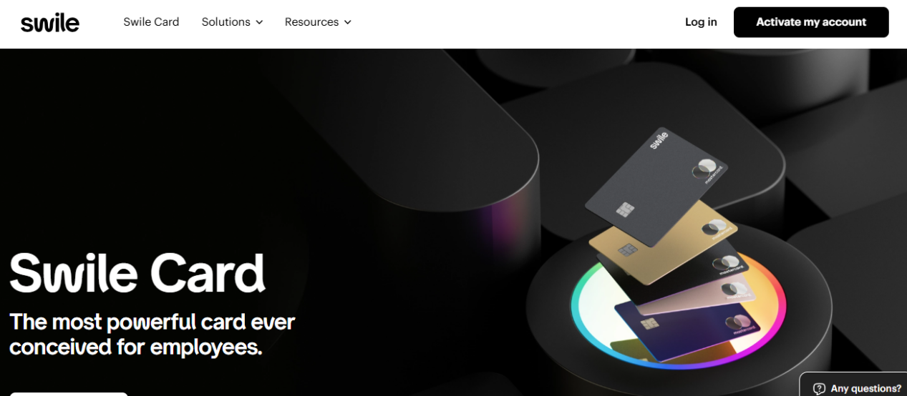

Figure 2.8: Swile
Overview: Swile is a digital employee benefits solution that integrates meal vouchers & the Swile Card, meaning companies can allocate tax-exempt lunches to employees for a reasonable amount which gets recharged on a monthly basis. This amount can be expended with 15,000+ partner merchants and spending tracking through the app and spending personalization (Swile, 2023).

Functional Requirements:
- Monthly allowance of meal fund recharged by employer
- Expenditure at 15k+ partner merchants via physical card or app
- Spending tracking and limits (spending caps) for self management
- Notifications when spending low and expenditures noted
- Company-wide redistribution management and tax-exempt limit management

Non-Functional Requirements
- Secure system with app accessibility that can scale per company needs
- Compliance with all French taxation requirements through exempt meals

System Analysis and Design:
- App with cloud-based backend for real-time tracking
- Ability to find partner merchants and auto-loaded through payroll
Requirement Analysis:
- Users (Employees): Flexible, non-taxable and easily tracked with personal limits
- Companies: Little maintenance and control over funding with a simplified legal obligation

Gaps & Weaknesses:
- Does not address university or student need; focused on corporate experience
- Merchant eligibility not specified from a transparency standpoint
- Needs to always be online, can't redeem without connection to the app

Strengths:
- Taxation incentive with many partners for easy use
- Personalized app access for satisfaction with spend tracking
- Business model should be translated for college meal allowance for better student benefit

CafePay: Cashless Payment Solution for Cafes
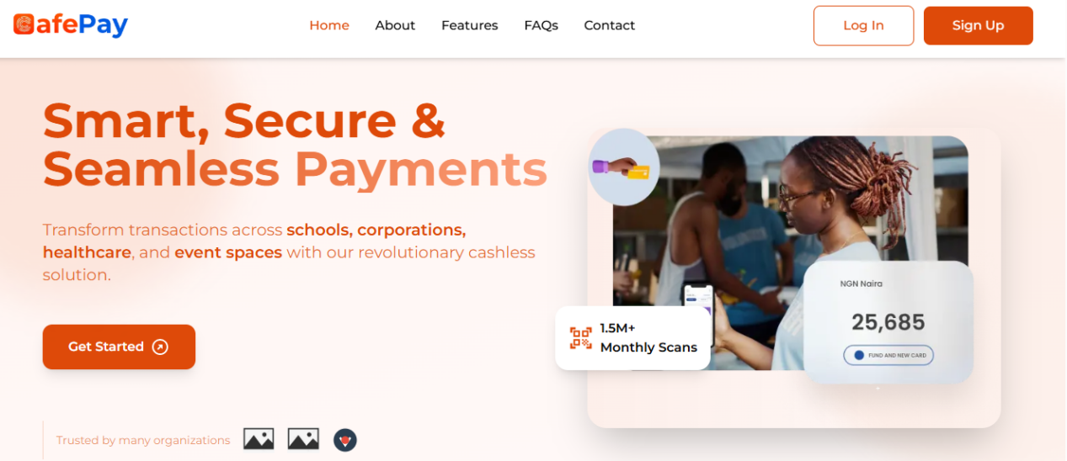

Figure 2.9: CafePay
Overview: CafePay (2023) is a cashless, QR-based payment option for corporates and institutions. It uses Cafe Cards to pay in real time, on the spot, by debit. It tracks usage and has inventory tracking and reporting features to minimize cash on hand and wait time.
Functional Requirements:
- QR scan on cards for real-time payment
- Mobile/Web application for digital reloading
- Awareness of daily spending and limit
- Awareness of daily consumption and expiration
- Sales and consumption report

Non-Functional Requirements:
- Encryption on security
- Applicable from small institutions to larger ones
- User friendly interface for all generations

System Analysis and Design:
- Admin portal for reporting is web based
- Scanner app for merchants is desktop based
- Funding and balance inquiry app is on mobile
- Optional integration with school/organization analytics systems

Requirement Analysis:
- Parents/students: secure transaction limits, enforcement and awareness
- Merchants: reduction in line waits, accurate inventory tracking and sales reports

Gaps & Weaknesses:
- Only works online, cannot be used for anything offline
- Doesn't support multiple currencies
- Must have scanner and physical card
- Cannot integrate with real time menus or ERP systems
Strengths:
- No cash conflicts/wasted food
- Real time projections of consumption and dietary notes
- Trusted system in Nigerian schools and best option for universities' canteens
Texfo: Nigerian E-Commerce Cart Platform
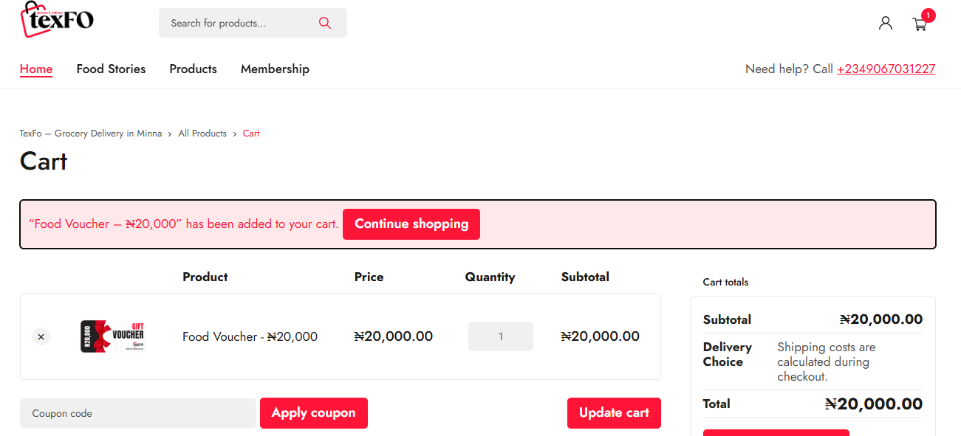

Figure 2.10: Texfo
Overview: Texfo (2016) is an e-commerce shopping cart system for users to log on to the internet and select items within seconds to place within a shopping cart and check out with a credit card all from the comfort of within Nigeria. The objective is to have the simplest operation possible with the most effective means of secure payment.

Functional Requirements:
- Add to a cart (digital and physical goods)
- Pay and check out using Nigerian merchant services.
- Confirm purchase and provide tracking.

Non-Functional Requirements:
- Fast loading time
- Mobile responsive
- Anonymous with e-commerce related security (XSS, CSRF, etc.).

System Analysis and Design:
- A standard cart that will be session based.
- Must factor in all merchant services available in Nigeria for integration.

Requirement Analysis:
- Buyers: Fast to implement and a bit complex purchase transaction.
- Sellers: Easy to add goods, instantaneous transaction confirmation.

Gaps & Weaknesses:
- Standard, required e-commerce system not specific to vouchers.
- Can't redeem right away, can't integrate on campus.
- No way to add on or keep meals in real time.

Strengths:
- Established means of payment processing.
- Easy, fast cart capabilities on the fly.
- Meals can be offered as a bundled package for on-campus integration.

Tinka: Food Voucher E-Commerce in Nigeria
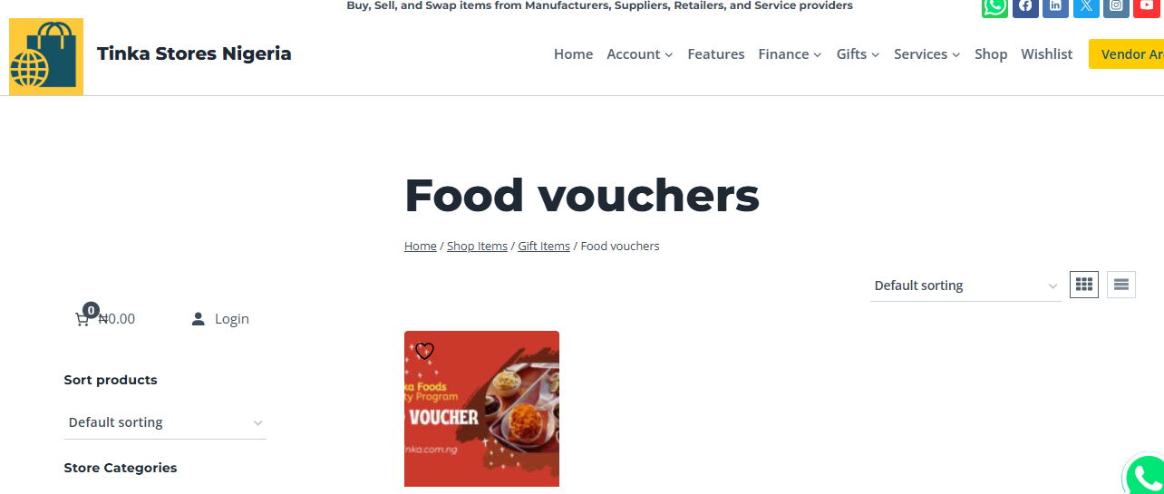

Figure 2.13: Tinka
Overview: Tinka (2018) is a digital food gift voucher store where Nigerians can buy physical and digital gift vouchers separated by type of food for quick access and selection with home delivery options.

Functional Requirements:
- Voucher purchase searching by type
- Add to cart then pay via CC/debit/online bank transfer
- Physical vouchers given through receipt
- Redemption acceptable only at partner outlets branch
Non-Functional Requirements:
- Secure transaction and one purchase redeemed per student
- System reliability of digital/physical payment and transaction time for delivery
- Nice cleanliness in design/interface and usability for purchaser navigation

System Analysis and Design:
- e-Commerce shop for all vouchers to be the purchased inventory
- Digital method to generate email/sms to customer and deliver.

Requirement Analysis:
- As recipients, its should be easy to purchase from many different food outlets
- As recipients, its easy to redeem for all (based on geographic proximity of where they live)
- As establishments, its easy for them to sponsor their establishments and get visibility for potential purchasers.

Gaps & Weaknesses:
- One use (no ability for it to be used/generate credits for re-use)
- No assessment in real time for how many have been redeemed of how many have been purchased
- No campus portal integration. no ERP evaluation.

Strengths:
- Niche market (only food vouchers)
- Locally Nigerian based brands
- Digital delivery (none needed for how long physical delivery would take) - much easier to give students meal credits

2.3.1 COMPARATIVE ANALYSIS OF RELATED WORKS

Table 2.1: Comparative Analysis
System | Digital | Real-Time Menu | Student Focus | Cost Impact | Fraud Resistance | Campus Integration
Chile Education Voucher | No | No | No | +25% public cost | Low | None
India Meal Voucher | No | No | No | Medium | Low | Corporate HR only
Italy Auction Model | No | No | No | Variable | Low | Public sector
Blockchain E-Voucher | Yes | No | Partial | High dev cost | High | Welfare agencies
Mensa Diffusa | Yes | Yes | No | Low per user | Medium | Local restaurants
Smart Gift | Yes | No | No | Market-leading rates | High (API secure) | Open API
Brandnamic Voucher App | Yes | Partial | No | Fixed license | High (GDPR) | PMS/POS
Circula | Yes | No | No | Not specified | High (AI validation) | Accounting tools
My DigiMenu | Yes | Yes | Partial | 2% fee | Medium | 300+ platforms
CafePay | Yes | Partial | Yes | Card issuance | High (QR encryption) | School systems
Chowdeck | Yes | Yes | No | Delivery fees | Medium | None
Texfo | Yes | No | No | Transaction fees | Low | E-commerce only
Tinka | Partial | No | No | Purchase price | Low | Gift sales only
Baze Smart Voucher | Yes | Yes | Yes | Zero marginal | High (QR validation) | Full ERP & Excel

2.3.2 Benefits of Related Systems
Voucher systems access more, cut costs and improve satisfaction in various settings via choice, the elimination of tangible systems, and digitized efforts; via transparency and security, My DigiMenu, CafePay, Chowdeck, Texfo and Tinka provide customizable loyalty, cashless payments, delivery and localized e-commerce for ultimate revenue and access.

2.3.3 Challenges Faced by Related Systems
Within the industry, significant switching costs, paper fraud, digital divides and no real time student data and systems such as Smart Gift and Circula (online only access with no transaction when offline), Chowdeck (delivers only, no attempted buy feature) and Tinka (gift only, no purchase features). Yet, none incorporate campus dining, dynamic menus, balance control and administrative reporting to position the innovative attractiveness of Baze Smart Voucher.

2.4 SUMMARY
From projected voucher systems to a conclusive timeline of education and welfare developments through modern day digital possibilities, the research outlines an established period of progression. Where modern day possibilities succeed at expanding options and reducing brick and mortar locations, they fail at exorbitant costs and susceptibility/fraud to a non-student centered and time efficient standard. Baze Smart Voucher is the first web-based, QR activated, all-encompassing university meal voucher program that digitalizes accessibility to an established success at minimal cost.

REFERENCES
Ahuja, R. (2016). Meal voucher system in India & its fiscal impact. Pahle India Foundation.

Auti, P., Bawankar, M., Bochare, P., & Harane, V. (2023). A review on smart canteen management system. International Journal for Research in Applied Science and Engineering Technology, 11 (11), 1199–1202. https://doi.org/10.22214/ijraset.2023.56698

Brandnamic Voucher App. (n.d.). Voucher app for hotels. Sell vouchers online. Brandnamic. https://www.brandnamic.com/en/voucher-app

CafePay. (n.d.). Cashless canteen payment for schools & corporates. https://cafepay.com.ng/

Chowdeck. (n.d.). Food & grocery delivery in Nigeria. https://chowdeck.com/

Cobee. (n.d.). Flexible meal voucher platform. https://cobee.io/en/meal-voucher/

Ginzberg, E. (1971). The economics of the voucher system. Teachers College Record, 72(3). https://doi.org/10.1177/016146817107200303

Hsu, C.-S., Tu, S.-F., & Huang, Z.-J. (2020). Design of an e-voucher system for supporting social welfare using blockchain technology. Sustainability, 12(8), Article 3362. https://doi.org/10.3390/su12083362

Kobas. (n.d.). Vouchers and promotions for hospitality. https://www.kobas.co.uk/products/vouchers-and-promotions/

Levin, H. M., & Driver, C. E. (1997). Cost of an educational voucher system. Education Economics, 5(3), 265–283. https://doi.org/10.1080/09645299700000023

Lissa’idah, L., Rosid, M. A., & Fitrani, A. S. (2019). Web-based canteen payment system with RFID technology. Journal of Physics: Conference Series, 1232(1), Article 012028. https://doi.org/10.1088/1742-6596/1232/1/012028

Mariani, M. (n.d.). The European “meal voucher” market and its evolution.

McEwan, P. J., & Carnoy, M. (2000). The effectiveness and efficiency of private schools in Chile’s voucher system. Educational Evaluation and Policy Analysis, 22(3), 213–239. https://doi.org/10.3102/01623737022003213

Monext. (2025). Meal vouchers: Unlocking new revenue with electronic payment solutions. Monext.

My DigiMenu. (n.d.). Contactless digital menu for restaurants. https://www.mydigimenu.com/

Pakpahan, A. F. (2019). Design and implementation of RFID card based authentication software in Universitas Advent Indonesia’s dining room. Abstract Proceedings International Scholars Conference, 7(1), 1794–1800. https://doi.org/10.35974/isc.v7i1.1975

Resmio. (n.d.). Coupon system for restaurants. https://www.resmio.com/en/restaurant- marketing/coupon-system/

Roson, R. (2005). Auctions in a two-sided network: The market for meal voucher services. Networks and Spatial Economics, 5(4), 339–350. https://doi.org/10.1007/s11067-005-6207-0

Samuel, O. M., et al. (2024). Development of an electronic meal ticketing system using RFID.

Smart Gift. (n.d.). Cloud-based voucher management platform. https://smart- gift.co.uk/

Swile. (n.d.). Employee benefits card system. https://www.swile.co/

Texfo. (n.d.). E-commerce cart for Nigeria. https://texfo.ng/cart/

Tinka. (n.d.). Food vouchers & gift items in Nigeria. https://tinka.com.ng/product- category/gift-items/food-vouchers/

